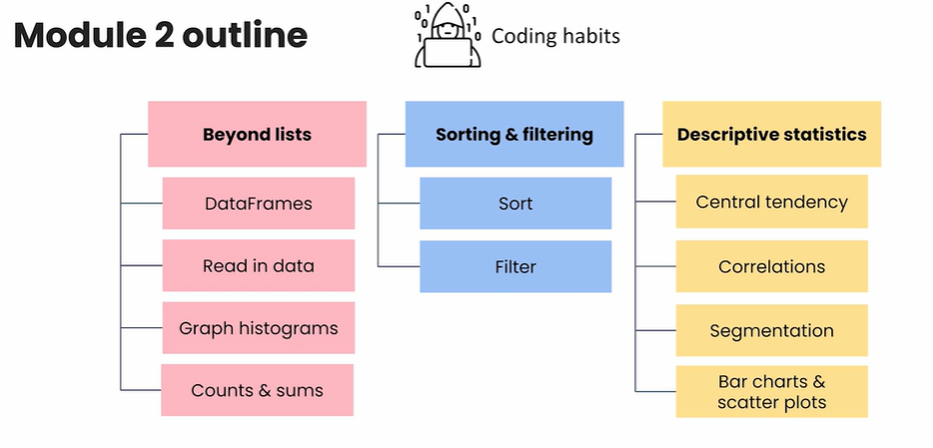

✅ MODULE 2 — Python Code Examples

🌸 1. BEYOND LISTS

1.1 DataFrames
import pandas as pd

data = {
"Product": ["A", "B", "C"],
"Price": [10, 20, 30],
"Units": [100, 150, 200]
}

df = pd.DataFrame(data)
print(df)

1.2 Read in data (CSV)
import pandas as pd

df = pd.read_csv("sales_data.csv")
print(df.head())

1.3 Graph histograms
import matplotlib.pyplot as plt

df["Price"].hist(bins=10)
plt.xlabel("Price")
plt.ylabel("Frequency")
plt.title("Price Distribution")
plt.show()

1.4 Counts & sums

Count occurrences
product_counts = df["Product"].value_counts()
print(product_counts)

Sum of a column
total_units = df["Units"].sum()
print("Total units sold:", total_units)

🔵 2. SORTING & FILTERING

2.1 Sort
df_sorted = df.sort_values("Price", ascending=False)
print(df_sorted)

2.2 Filter

Filter rows where Price > 15
filtered = df[df["Price"] > 15]
print(filtered)

Filter by multiple conditions
filtered = df[(df["Price"] > 15) & (df["Units"] < 200)]
print(filtered)

🟡 3. DESCRIPTIVE STATISTICS

3.1 Central tendency (mean, median, mode)
import statistics as stats

print("Mean:", df["Price"].mean())
print("Median:", df["Price"].median())
print("Mode:", df["Price"].mode()[0])

3.2 Correlations
corr = df[["Price", "Units"]].corr()
print(corr)

3.3 Segmentation (GroupBy)
Group by product and calculate total units:
segments = df.groupby("Product")["Units"].sum()
print(segments)

3.4 Bar charts & scatter plots

Bar chart
df.groupby("Product")["Units"].sum().plot(kind="bar")
plt.ylabel("Units Sold")
plt.title("Units Sold by Product")
plt.show()

Scatter plot
plt.scatter(df["Price"], df["Units"])
plt.xlabel("Price")
plt.ylabel("Units")
plt.title("Price vs Units Sold")
plt.show()

📌 Python Cheatsheet — Module 2 (Pandas + Matplotlib)
Topic | Code Example | Notes
Import libraries | import pandas as pd  import matplotlib.pyplot as plt | Pandas = data handling, Matplotlib = plotting
Load CSV data | df = pd.read_csv("data.csv") | Works for .csv. Use read_excel for Excel.
View first rows | df.head() | Quick view of dataset
Check structure | df.info() | Shows types + missing values
Select a column | df["price"] | Returns a Series
Select multiple columns | df[["product", "price"]] | Returns DataFrame
Filter rows (condition) | df[df["price"] > 20] | Basic filtering
Filter with multiple conditions | df[(df["category"]=="Toys") & (df["price"] < 10)] | Use & and `
Sort values | df.sort_values("price") | Ascending by default
Sort descending | df.sort_values("price", ascending=False) | Highest → lowest
Count rows | df.shape[0] | Number of records
Sum a column | df["sales"].sum() | Total sales
Group by + sum | df.groupby("category")["sales"].sum() | Category-level totals
Group by + count | df.groupby("category")["product"].count() | Count items in each group
Histogram | df["price"].hist()  plt.show() | Price distribution
Bar chart | df.groupby("category")["sales"].sum().plot(kind="bar") plt.show() | Summed sales by category
Scatter plot | df.plot(kind="scatter", x="advertising", y="sales") plt.show() | Relationship between variables
Mean / average | df["price"].mean() | Central tendency
Median | df["price"].median() | Middle value
Mode | df["price"].mode() | Most frequent value
Standard deviation | df["price"].std() | Spread of data
Correlation matrix | df.corr() | Numeric correlations
Correlation heatmap (simple) | plt.imshow(df.corr(), cmap="viridis")  plt.colorbar() | Visualize correlations
Unique values | df["category"].unique() | All distinct labels
Value counts | df["category"].value_counts() | Count per category
Add a new column | df["total"] = df["price"] * df["quantity"] | Derived metric
Drop column | df.drop("old_col", axis=1, inplace=True) | Remove unwanted column

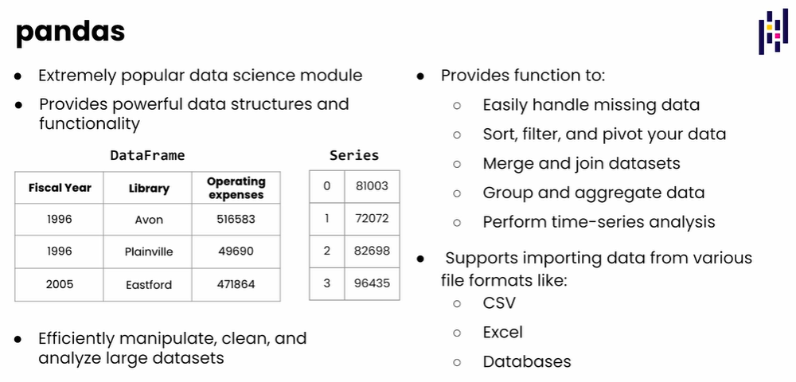

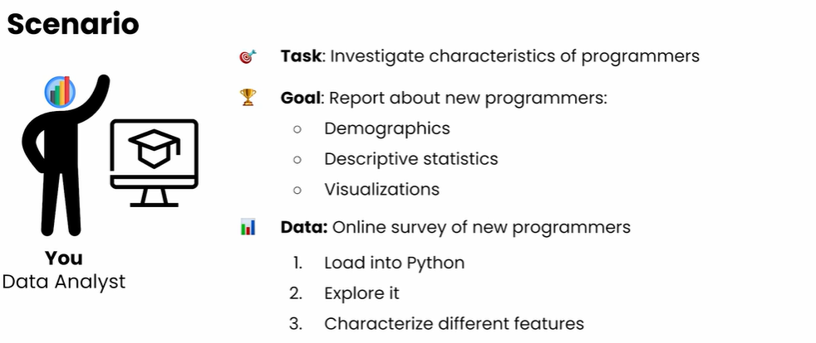
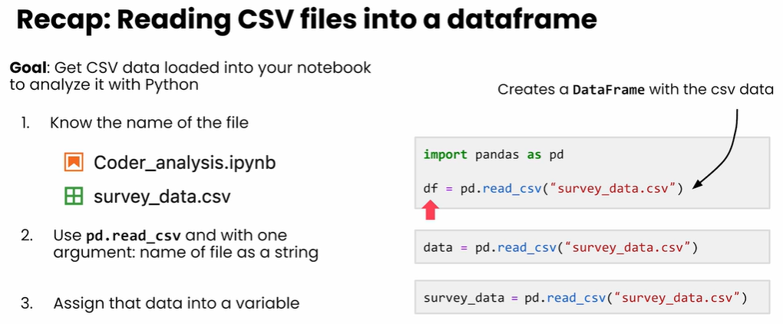
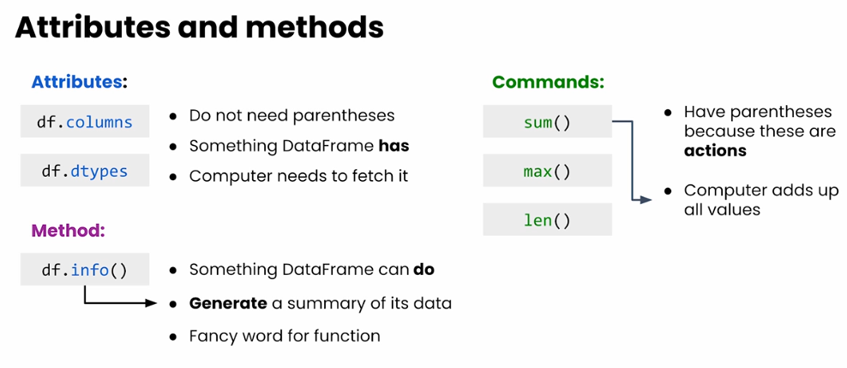
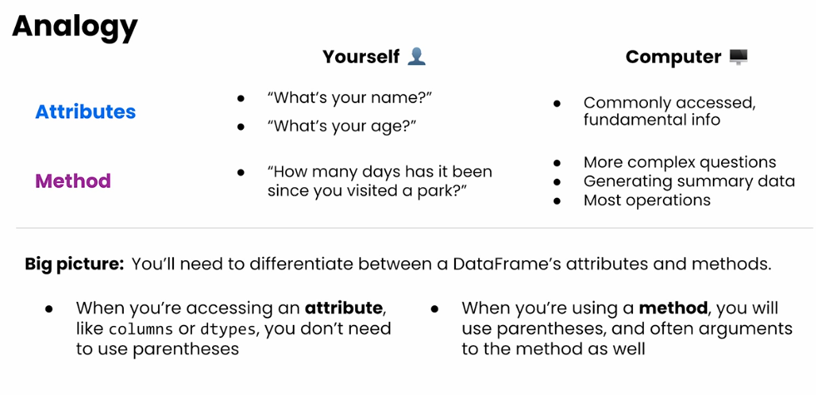

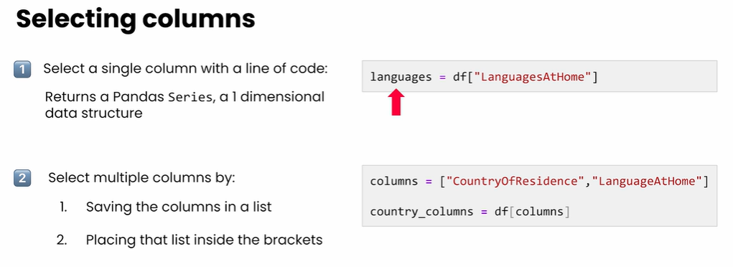

⭐ Summary Cheat Sheet (Very Simple)
Task | Code | Output
Select one column | df["Column"] | Series
Select many columns | df[["Col1", "Col2"]] | DataFrame
List unique values | pd.unique(df["Column"]) | ndarray
View first rows | .head() | First 5 rows
Length of column | len(df["Column"]) | Number of rows
Random sample | .sample(5) | 5 random rows

💯 This is what you wanted — a command-only table.
Task | Code
Load data | df = pd.read_csv("coding_survey.csv")
Preview data | df.head()
Data summary | df.info()
Select column | age = df["age"]
Count non-null values | age.count()
Count nulls | df.isna().sum()
Count non-null by column | df.count()
Column length | len(age)
Describe stats | age.describe()
Histogram | age.hist()
Prettier histogram | age.hist(bins=20, edgecolor="black", grid=False)
Sum numeric column | hours.sum()
Multiple histograms | df[["age","hours_learning","money_spent"]].hist()
Assign multiple columns | hours = df["hours_learning"]

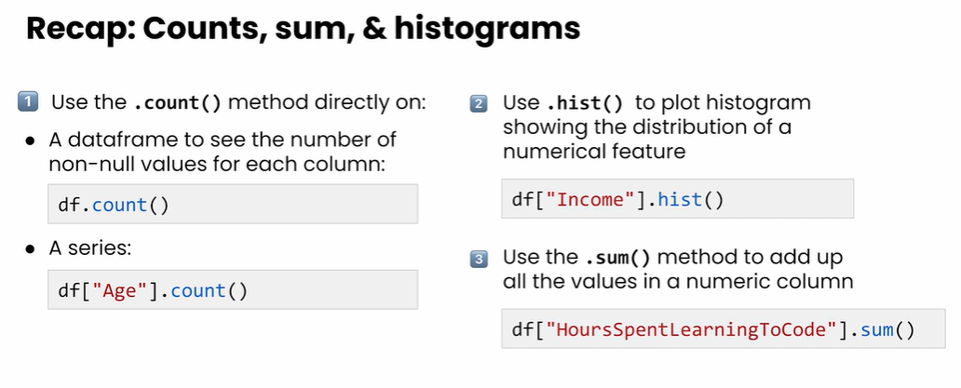
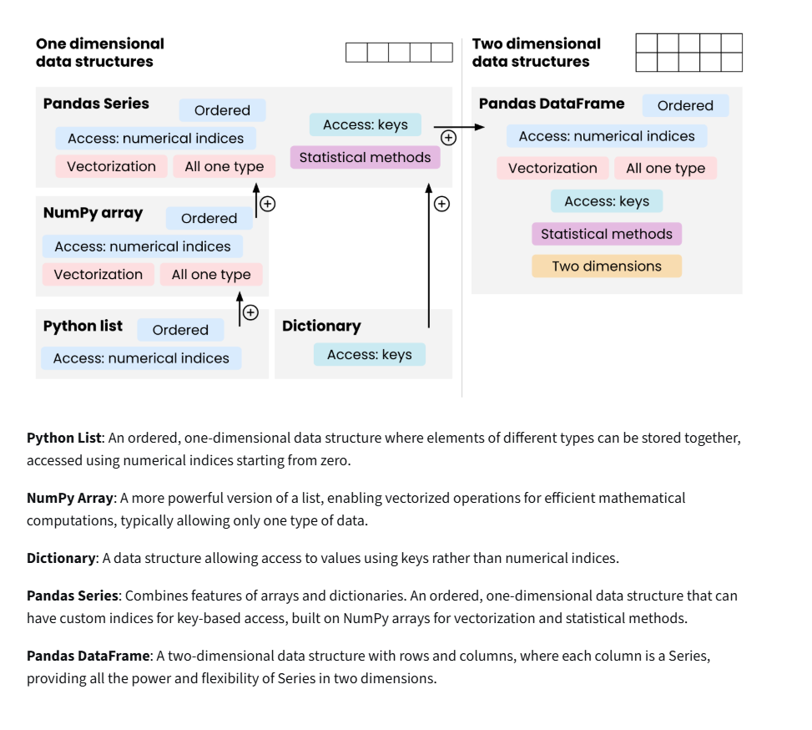

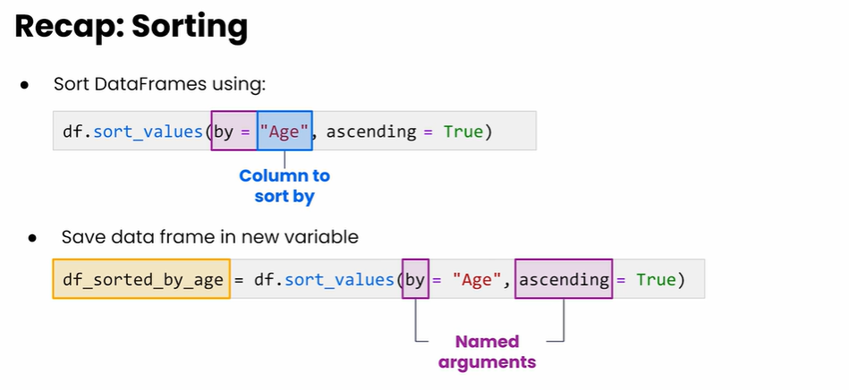

✅ Sorting Commands in Pandas (Table)
Command | Description
df.sort_values(by="age") | Sorts ascending (default)
df.sort_values(by="age", ascending=False) | Sorts descending
df.sort_values(by=["age", "income"]) | Sorts by multiple columns (ascending)
df.sort_values(by=["age", "income"], ascending=[True, False]) | Multi-column with mixed sort order
df.sort_values(by="age", inplace=True) | Sorts and modifies the original DataFrame
df.sort_values(by="age").head() | View first sorted rows
df.sort_values(by="age").tail() | View last sorted rows

✅ Minimal Working Example
import pandas as pd

df = pd.read_csv("survey.csv")

df_sortedByAge = df.sort_values(by="age")

✅ Descending Example
df_sortedByAge = df.sort_values(by="age", ascending=False)

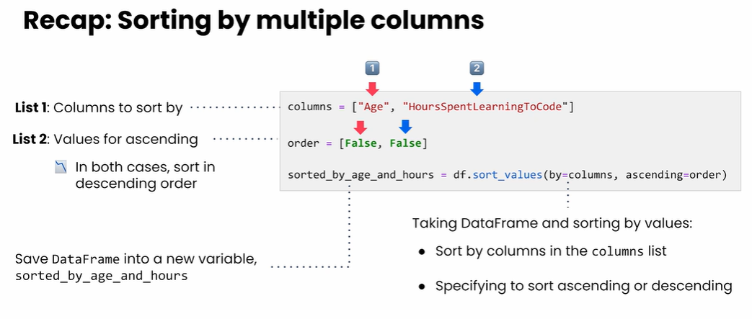
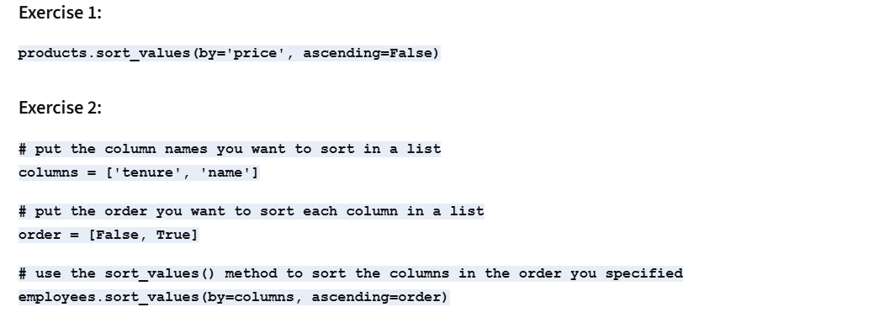
Here is a clear table of filtering commands in pandas with examples based on the text you provided:

✅ Filtering Data in Pandas (Table)
Command | Description
df["gender"].unique() | Show unique values in a column
df[df.gender == "female"] | Filter rows where gender is female
df[df.gender != "male"] | Filter out males
df[df.age > 30] | Filter numeric column (greater than)
df[df["hours_learning"] >= 30] | Filter numeric (greater or equal)
df[df.age < 18] | Filter numeric (less than)
df[df.gender.isna()] | Select missing/NaN values
df[df.gender.notna()] | Select non-missing values

✅ Boolean Filtering Example
female_respondents = df[df.gender == "female"]
Result:
- type: DataFrame
- keeps original index
- only rows where gender == "female"

✅ Numeric Filtering Example
above_30 = df[df.age > 30]

✅ What happens internally?
df.gender == "female" produces:
False, False, False, True, True, ...
The DataFrame keeps only rows where the value is True.

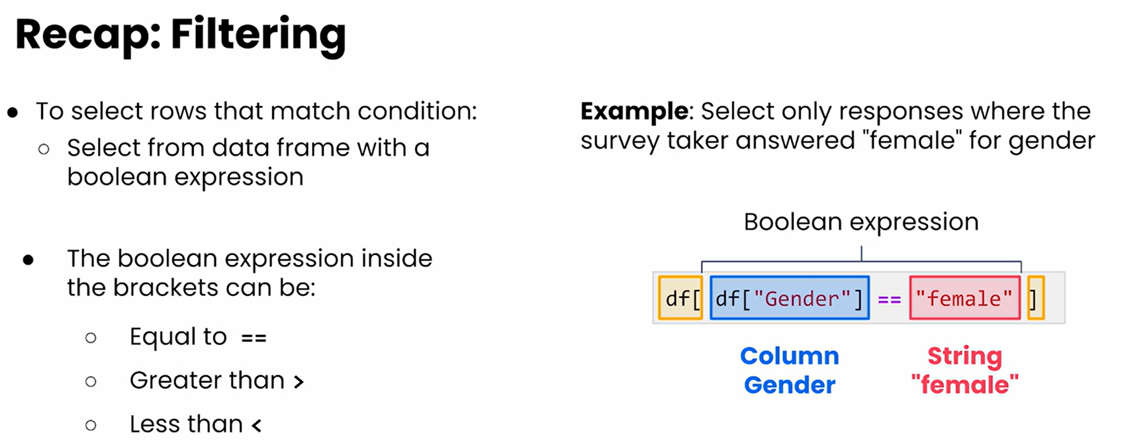
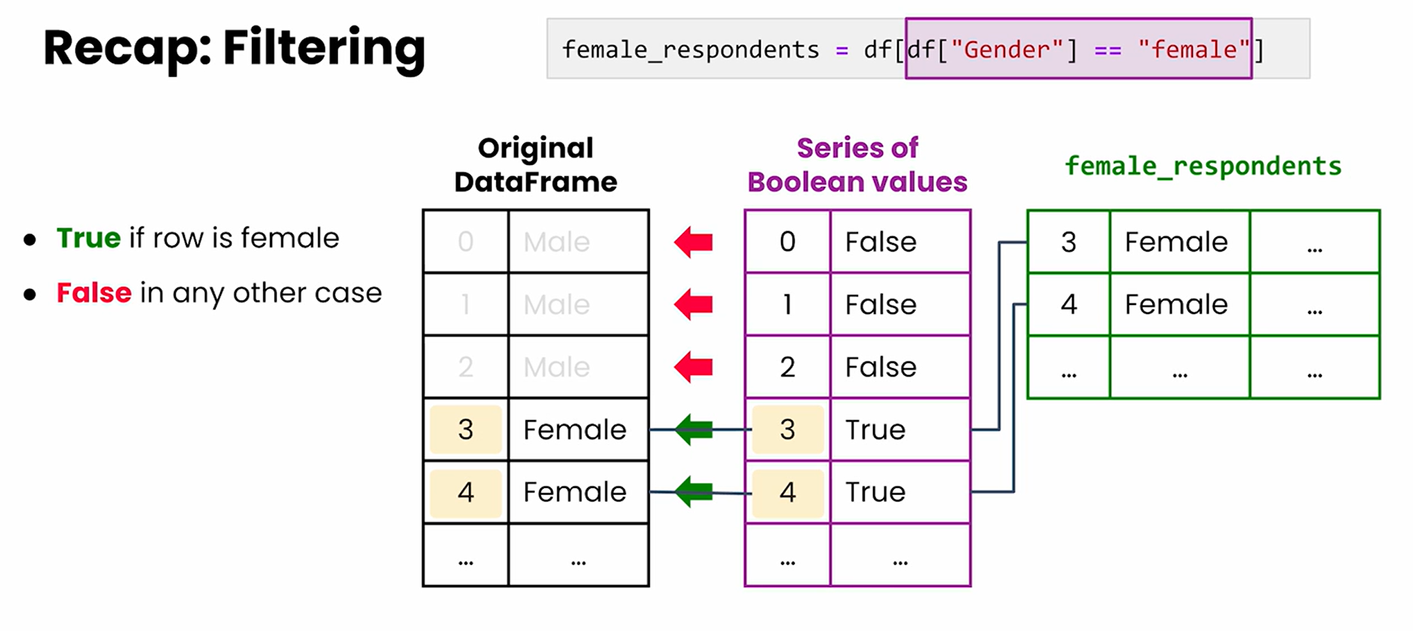

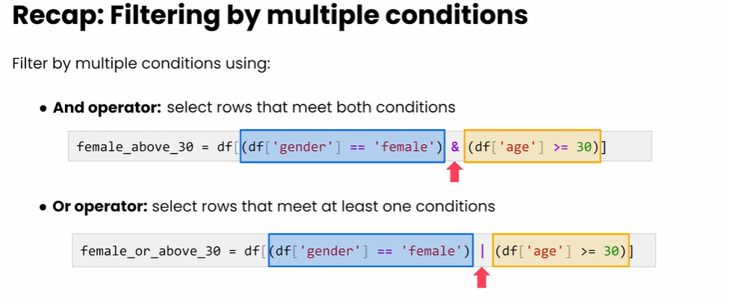

📘 Table: Filtering With Multiple Conditions in pandas
Task | Command / Code | Meaning
Select females only | df[df["gender"] == "Female"] | Basic single-condition filtering
Select age > 30 | df[df["age"] > 30] | Filter numeric values greater than 30
Combine: Female AND age > 30 | df[(df["gender"] == "Female") & (df["age"] > 30)] | Both conditions must be true
Combine: Female OR age > 30 | `df[(df["gender"] == "Female") | (df["age"] > 30)]`
NOT female | df[~(df["gender"] == "Female")] | Select all non-female rows
Save to variable (AND example) | females_above_30 = df[(df["gender"] == "Female") & (df["age"] > 30)] | Store filtered data
Count rows in filtered df | len(females_above_30) | Includes null rows
Count non-null values | females_above_30.count() | Column-wise count excluding nulls
View sample rows | females_above_30.sample(10) | Random 10 rows for verification
Chain 3 conditions | df[(df.age > 30) & (df.gender == "Female") & (df.country == "USA")] | Typical multi-condition filter
Check age is between two values | df[(df.age > 20) & (df.age < 40)] | Use AND for a range
Using .isin() for multiple categories | df[df["country"].isin(["USA", "UK", "Germany"])] | Filter by list of values

Exercise 1:
# filter the dataframe for 'Male' patients to a variable named patients_male patients_male = patients[patients['gender'] == 'Male']
# print the results
print(patients_male)

Exercise 2:
# filter the dataframe for 'Male' patients with 'bmi' >= 30 # save to a variable named patients_male_high bmi
patients_male_highbmi = patients[(patients['gender'] == 'Male') & (patients['bmi'] >= 30)]
# print the results print
(patients_male_highbmi)

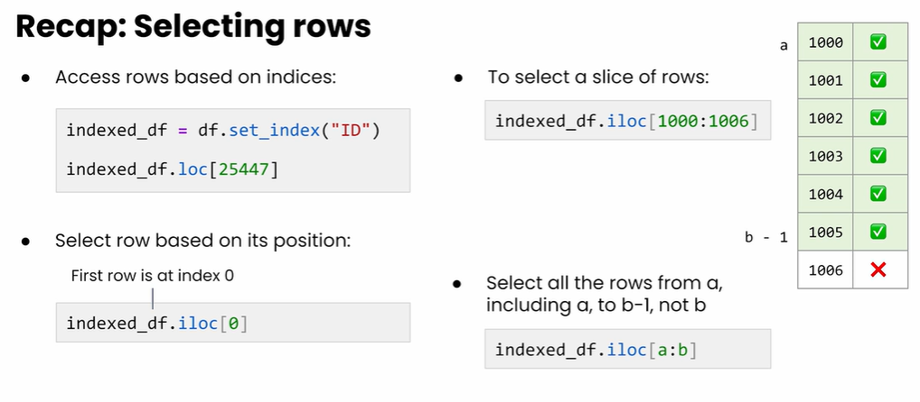 (row selection, .set_index(), .loc, .iloc, slicing, series indexing, etc.).

📘 Table: Selecting & Slicing Rows in pandas
Task | Command / Code | Explanation
Set a column as the DataFrame index | indexed_df = df.set_index("ID") | Replaces numeric index with unique ID column
View first 5 rows | indexed_df.head() | Confirms that ID is now the index
Select row by custom index (ID) | indexed_df.loc[25447] | Uses .loc to find a row by label (ID)
Select row by integer position | indexed_df.iloc[1000] | Returns row at position 1000 (zero-indexed)
Save selected row into variable | response_1000 = indexed_df.iloc[1000] | Stores single row as a Series
Check type of row | type(response_1000) | Will return: pandas.core.series.Series
Select a value from a row (Series) | response_1000["age"] | Use the column name as key
Slice 5 rows starting at integer index 8664 | range_of_rows = indexed_df.iloc[8664:8669] | Selects rows 8664 → 8668 (5 rows)
Check type of slice | type(range_of_rows) | Returns: pandas.core.frame.DataFrame
General slice rule | df.iloc[a:b] | Returns rows from a to b−1, not including b
Example: 6-row slice | df.iloc[1000:1006] | Length = 1006 − 1000 = 6
Select multiple rows by list of indices | indexed_df.loc[[25447, 18922, 90011]] | Provide multiple custom index labels
Reset index back to numeric | df_reset = indexed_df.reset_index() | Moves old index back into a column

📘 Bonus: Quick Reference for .loc vs .iloc
.loc | .iloc
Label-based selection | Integer position-based selection
Works with strings, numbers, dates | Only works with integer positions
Includes end of slice → df.loc['A':'D'] | Excludes end of slice → df.iloc[10:15]
Example: df.loc[25447] | Example: df.iloc[0]

📊 Series vs. DataFrame vs. List (Simple Explanation)
Object | Type | Shape | What it Represents | When to Use It | Example
Series | 1-dimensional (like one column) | (n,) | A column of data with labels (index) | When working with a single column | age = df["age"]
DataFrame | 2-dimensional (rows × columns) | (n, m) | A table of data — multiple columns | When working with a dataset/table | df
List (Python built-in) | 1-dimensional | varies | A general-purpose Python list — no labels, no columns | Before loading into pandas, or general Python ops | [10, 20, 30]

🧠 Key Differences (Quick Summary)
Feature | Series | DataFrame | List
1D / 2D | 1D | 2D | 1D
Index | ✔ Yes | ✔ Yes | ✘ No
Column names | ✘ No | ✔ Yes | ✘ No
Vectorized ops (+, mean, etc.) | ✔ Yes | ✔ Yes | ✘ No
For real data analysis | ✔ | ✔ | ✘ (not directly)

🎯 When should you use each?

Use a DataFrame when:
- You are working with a dataset
- You need columns
- You need filtering, merging, grouping, stats

Use a Series when:
- Selecting one column
- Selecting one row
- Working with a list of values with labels

Use a List when:
- Doing general Python
- Before loading data into pandas
- Creating dummy values

📘 Pandas Selection Cheat Sheet (Table Summary)
Method | Type of Selection | Uses Labels or Integers? | Can Select Rows? | Can Select Columns? | Best For | Example
Brackets [ ] | Column selection & Boolean row filtering | Column labels only | ✔ Yes (Boolean filtering) | ✔ Yes (single column) | Quick column pick, simple filters | df["Age"] ; df[df["Age"] > 30]
.at | Single scalar value | Labels | ✔ Yes | ✔ Yes | Fastest way to get/set one cell | df.at[2, "A"]
.loc | Label-based rows & columns | Labels | ✔ Yes | ✔ Yes | Slicing by labels, conditional filtering | df.loc[df["Age"] > 30] ; df.loc[0:3, ["Age","Gender"]]
.iloc | Position-based rows & columns | Integer indices | ✔ Yes | ✔ Yes | When labels are unknown or numeric | df.iloc[0:3, 0:2]
.query() | Conditional filtering using string expressions | Column names (as variables) | ✔ Yes | ✘ No (columns selected via expression) | SQL-like queries, readable conditions | df.query("Salary > 50000")

🧠 Quick Visual Summary

✔ Brackets [ ]
- For columns → df["Name"]
- For row filtering → df[df["Age"] > 30]
- ❌ Cannot select row+column together.

✔ .at
Fast access to a single cell (label-based).
df.at[2, "A"]

✔ .loc
Label-based selection (rows & columns):
df.loc[df["Age"] > 30] # filter rows
df.loc[0:3, ["Age", "Gender"]] # row slice + columns

✔ .iloc
Integer position selection:
df.iloc[0:3, 0:2]

✔ .query()
Readable filter using strings:
df.query("Salary > 50000")
df.query("Age > 30 and Gender == 'Female'")

⭐ When to Use What? (One-Liners)
- [ ] → Quick picks (column or simple filter)
- .at → Fastest for a single value
- .loc → Use when you know labels or need conditions
- .iloc → Use when selecting by integer positions
- .query → Use when you prefer SQL-style filtering

✅ Practice Exercises (Original, Not From Coursera)

Question 1
What is the type of the result when selecting a single column from a DataFrame in Pandas?
Options:
- A) List
- B) DataFrame
- C) Series
- D) Dictionary
Explanation (after answering):
Selecting a single column like df["col"] returns a Pandas Series.

Question 2
What does the following line of code do?
df.set_index("EmployeeID")
Options:
- A) Renames the "EmployeeID" column
- B) Removes the "EmployeeID" column
- C) Sets "EmployeeID" as the new index of the DataFrame
- D) Sorts the DataFrame by "EmployeeID"
Explanation (after answering):
.set_index() replaces the current row indices with the values from the specified column.

Question 3
What will the variable subset contain after running this code?
subset = df[df["Salary"] < 40000]
Options:
- A) A boolean Series
- B) A filtered DataFrame with only rows where Salary is less than 40000
- C) The "Salary" column
- D) A single integer value
Explanation (after answering):
Boolean filtering returns a subset DataFrame, not a single column or value.

Question 4
What does the argument ascending=False do in this code?
df.sort_values("Age", ascending=False)
Options:
- A) Sorts by index
- B) Sorts ages from largest to smallest
- C) Removes rows with missing Age values
- D) Randomizes the order of rows
Explanation (after answering):
ascending=False means the column is sorted in descending order.

Question 5
What is the purpose of .iloc in Pandas?
Options:
- A) Select rows and columns by labels
- B) Select rows and columns by integer position
- C) Select columns only
- D) Modify the index
Explanation (after answering):
.iloc = integer-location, used for positional selection.

Question 6
Which command filters rows where Gender is "Female" AND Age > 40?
Options:
- A) df[df["Gender"] == "Female" or df["Age"] > 40]
- B) df[df["Gender"] == "Female" & df["Age"] > 40]
- C) df[(df["Gender"] == "Female") & (df["Age"] > 40)]
- D) df.query("Gender == 'Female' AND Age > 40")
Explanation (after answering):
Correct syntax uses parentheses and &.

Question 7
What does the following return?
df.loc[105]
Assume 105 is an index label.
Options:
- A) A single integer
- B) A Series with all column values for index 105
- C) A single column
- D) A DataFrame with multiple rows
Explanation:
.loc returns the row with that label, as a Series.

